Project Proposal

**Online Shopping website**

**ZHENG ZENGHAO**

**CST1909171**

**SUPERVISIOR:**

**SUBASHINI RAGHAVAN**

## Introduction:

With the development of China’s economy, Chinese entities are facing more and more competitive pressure. Companies must use some information technology to improve management efficiency and increase sales. E-commerce is a new business model in the era of the increasing development of the Internet. Based on browsers, it can realize online shopping, transactions between merchants and online payment. As a new shopping method, online shopping has brought huge convenience and influence to people. The past decade has seen rapid growth in the demand for online shopping opportunities in China. According to the Figure1, the number of online shoppers in China has been increasing exponentially from below 200 million in 2011 to over 800 million users a decade later, enabling this enormous spurt of China’s e-commerce sector.

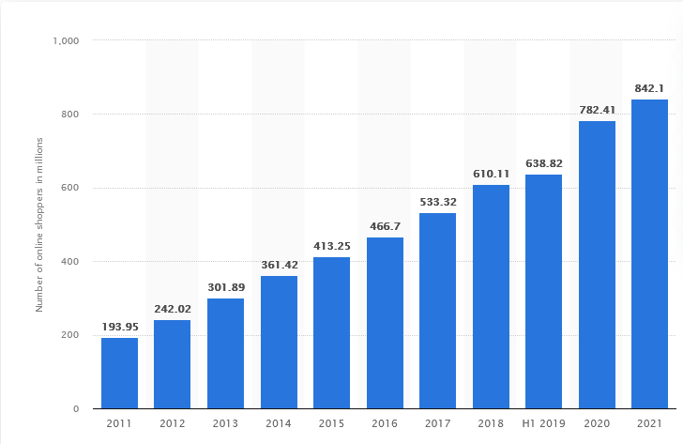

Figure1: Number of online shoppers in China[1]

What more, because of the impact of covid-19, there exist a rapid increasement during year 2019 to 2020, and china are still under the impact of the epidemic, so it’s a good chance to develop an online shopping website at present. In this paper, we will introduce online shopping behavior and how to design a website that can attract customers.

## Literature Review

**2.1 Online shopping behavior**

Consumer buying behavior refers to the study of customers and how they behave while deciding to buy a product that satisfies their needs. It is a study of the actions of the consumers that drive them to buy and use certain products. The study of consumer buying behavior is most important for us as they can understand the expectation of the consumers. It helps to understand what makes a consumer buy a product. It is important to assess the kind of products liked by consumers so that they can release it to the market. Marketers can understand the likes and dislikes of consumers and design base their marketing efforts based on the findings. [2] examined the effects of visual, navigational, and informational website design characteristics on consumers' perceived irritation in online shopping activities. The results of data collected from online shoppers showed that the three website design characteristics had significant negative effects on perceived irritation in online shopping context. [3] proposed a research model of online shopping behavior. They

argues the trust positively affects online shopping behavior; perceived website complexity negatively and directly affects online shopping behavior, and indirectly affects trust online shopping behavior via trust.

* 1. **Product search system**

[4] proposed a novel commodity search system to track consumer demand, and that is, when the commodity price of any website is lower than the consumer price conditions, the system will proactively notify consumers. This study results indicate that the novel commodity search system could assist consumers to search commodity, and provide historical price information of commodity for consumers

to decide. [5] The proposed model includes the using of data mining techniques for knowing which classification algorithm fit well user's data analysis, which will be next using in developing the user profile ontology. The results indicated that the Decision table algorithm gives the highest TPR by (0.871).

**Aim**

This paper is aimed to build an online website and based on the website analyzing the online shopping behavior and how website design can attract the customers. This website will take use of some product recommendation algorithm to improve the chance customer make payment when customer browse the web page.

**Project Objective**

* To develop a Front-end and back-end separation website based on python and html.
* To implement recommendation algorithm in customer browse page.
* To evaluate the website and its efficacy in satisfying the customer’s need

**Project Scope**

The scope is defined as follows:

* The predictions focus on China only
* Python is used for this project

**Problem Statement**

Nowadays, more and more online shopping website appears, how we should do to attract customer do online shopping in our website? And how to increase the sales of our shopping website based on some recommendation algorithm?

**Methodology research**

1. Which model want to use?

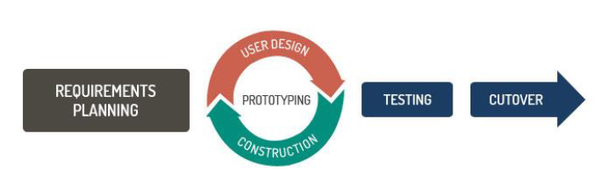RAD model: Since online shopping website is object-oriented, so maybe we need to fix some bugs or change some functions based on the feedback of customer. According to the RAD model, we can reduce the risk and required efforts on the part of the software developer and can justify the website based on the customer’s feedback

1. What development tools and frame will be used?

In this paper, we will use Python, html and css as programming language to realize the front-end and back-end of the website and we will use MySQL to store the value of the customer information and products information. F or the framework, we will use Django. Django is a free, python-based, open-source web development framework that facilitates clean and rational designing of websites driven by databases. It reduces a lot of hassles that a developer has to face during the development of a website. [5] And we will use k-means algorithm to realize recommendation function.

1. Data source
2. Do survey
3. Obtain some data from online website.

**Experimental design**

Step1: Do survey:

1. recommend shopping way.

2. why choose online shopping.

3. the biggest problem customer thought about online shopping

Step2: Study K-means algorithm and Django framework.

1. Utilize online resource to learn k-mean algorithm.
2. Learn how to use Django framework to create website

Step3: Create the database based on the website requirement

Step4: Developing the website based on the tools and algorithm mentioned above

Step5: Collect the feedback of the customer

Step6: According to the feedback of the customer, fix some bugs and add some properly functions.

**Project Timeline**

**REFERENCES**

[1] Retrieved from https://www.statista.com/

[2] Bassam Hasan, Perceived irritation in online shopping: The impact of website design characteristics, Computers in Human Behavior, Volume 54,2016, Pages 224-230, ISSN 0747-5632, Retrieved from <https://doi.org/10.1016/j.chb.2015.07.056>. (https://www.sciencedirect.com/science/article/pii/S0747563215300686)

[3] H. Cheng and T. Fu, "The Determinants of Online Shopping Behavior," 2018 International Conference on Intelligent Autonomous Systems (ICoIAS), 2018, pp. 97-100, doi: 10.1109/ICoIAS.2018.8494098.

[4] M. Ying and Y. Hsu, "A commodity search system for online shopping based on ontology and web mining," International Conference on Software Intelligence Technologies and Applications & International Conference on Frontiers of Internet of Things 2014, 2014, pp. 6-11, doi: 10.1049/cp.2014.1526.

[5] R. A. El-Deen, S. Morsi and N. Magdi, "Using Semantic Web Technology and Data Mining for Personalized Recommender System to Online Shopping," 2018 International Conference on Computer and Applications (ICCA), 2018, pp. 358-363, doi: 10.1109/COMAPP.2018.8460300.

[6] Retrieved from https://squareboat.com/blog/top-14-pros-of-using-django-framework-for-web-development